**(e) Sealing Strategy for ROV Enclosures**

Waterproofing is critical for the ROV’s performance and durability. The sealing approach protects electronic components while maintaining structural integrity under varying pressures. This design integrates 3D-printed PETG, aluminum, high-performance adhesives, and mechanical fasteners for optimal sealing efficiency.

**Main Canister Sealing (Electronics Housing)**

* **Sealing Mechanism:**
  + Sikadur-31 CF adhesive prevents micro-gaps.
  + IP68-rated metallic cable glands ensure watertight cable entry.
  + Epoxy resin & super glue reinforce adhesion.
  + Bolted fastening ensures long-term stability.

**Camera Housing Sealing**

**ZED Camera Enclosure**

* **Sealing Mechanism:**
  + O-ring in a groove forms a primary seal.
  + RTV Gasket Maker provides additional waterproofing.
  + Compression sealing & Allen bolts apply uniform pressure.
  + Sikadur-31 CF protects against water exposure.

**Artelon Camera Enclosures**

For other cameras, Artelon enclosures replace aluminum.

* **Sealing Mechanism:**
  + Acrylic cover sandwiched with an O-ring seal ensures water resistance.
  + Allen bolts provide tight compression for long-term sealing.

**Bolt Spacing Calculation for Optimal Sealing**

To ensure optimal sealing pressure and prevent gasket deformation under load, the bolt spacing (C) is calculated based on flange stiffness, gasket pressure, and deflection using the following equation:

$$C=[\frac{480 \left(\frac{a}{b}\right)Et^{3}∆H}{13P_{min}+2P_{max}}]^{\frac{1}{4}}$$

where:

C = Bolt spacing (mm)

a = Width of the flange plate (mm)

b = Width of the gasket (mm)

E = Modulus of elasticity of the flange material (Pa or N/m²)

t = Thickness of the flange (mm)

ΔH = Max. gasket deflection - Min. gasket deflection (mm)

Pmin = Minimum gasket pressure (Pa or N/m²)

Pmax = Maximum gasket pressure (Pa or N/m²)

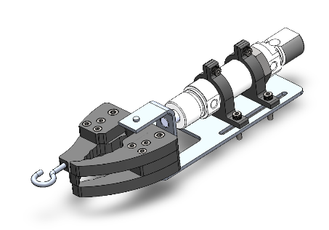**(g) Grippers**

Two claw grippers are designed to handle various item shapes and diameters. They are constructed from 10mm HDPE for durability and aluminum for fixation, ensuring a lightweight yet sturdy design.

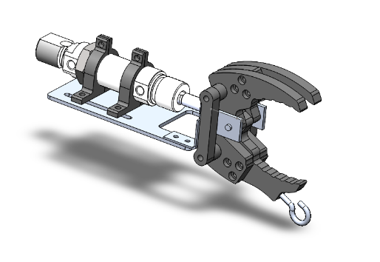The grippers are pneumatically actuated using a 25mm stroke piston that applies 113–135N of force in both forward and backward directions. With a maximum opening width of 70mm, they can securely grip all required competition objects.

a)

To enhance functionality, two screw hooks were integrated, enabling the ROV to lift hooks and manipulate ropes, expanding its operational capabilities.

Fig (): a) Horizontal Gripper, b) Vertical Gripper

b)

To optimize the gripper’s design and prevent potential bending stress-induced failures, a comprehensive stress analysis was performed. This theoretical evaluation ensured the gripper’s ability to withstand the designated weight. The results confirmed that:

* The **horizontal gripper** can hold up to **14.6 kg**.
* The **vertical gripper** can hold up to **11.8 kg**.
* A blue model of a mechanical device

  AI-generated content may be incorrect.A blue device with a rainbow of color

  AI-generated content may be incorrect.Both with a **safety factor of 2**.

b)

a)

Fig (): a) Horizontal Gripper analysis b) Vertical Gripper analysis